Creolization across the Indian Ocean: Language and Culture

Created by: Bria Reel
Overview and Purpose:

During the Medieval and First Global Eras, The Indian Ocean basin had witnessed the rise of trade and exploration. Between 300 CE and 1770 CE, the volume of networks connecting Southeast Asia, India, the Arabian Peninsula, China, and East Africa expanded exponentially. As the urge to travel and trade over longer distances increased, the impact on local communities and their cultures were also affected. Series of social, economic, religious, and technological exchanges ensued. In this lesson plan, the students will examine how the paradigm of language acts as a summary of these cultural exchanges. They will learn how new networks of human interaction served as a catalyst for creolization or mixing of languages and cultures. Throughout this lesson, the students will observe this phenomenon by utilizing the Indian Ocean in World History (IOWH) website. Students will research the history of major port cities in the Indian Ocean, examine multiple accounts of creolization from iconic medieval travelers, and witness the continuation of creolization in the Swahili language today.

In Part I of this lesson, students will briefly be introduced to the Indian Ocean Trade with overviews of the Medieval and First Global Eras. Students will use this reading to get a general sense of what is happening in the region during this period. The instructor should encourage the students to think critically about what made these cultures intertwine, and how it compares to other examples of creolization and global trade that they have already learned about. In Part II, the students will be able to share their discoveries in a class discussion through questions. In Part III, the students will begin to unfold the many layers of this phenomenon by completing the worksheet and maps given in the handout. The handout will cover events and the significance of major port cities from the Medieval Era leading into the First Global Era. Once all of the students have completed their research, the students will continue to Part IV where they will take a quiz on the information that they have just researched. After the quiz, the final portion of the lesson will be focusing on the Swahili case study. The class will begin by watching the short video, Africa Insights: The Swahili Language, found on YouTube or below in the cited links. After the video, the class will engage in a game where the students will identify the influences that Arabic, Hindi, Portuguese and Persian have on the Swahili Language.

Pedagogical Goals:
After completing this lesson on Creolization across the Indian Ocean: Language student should be able:
- To understand that the movement of peoples can have a direct effect on language and culture;
- To highlight the history of trade and exploration during the Medieval and First Global Eras on the Indian Ocean Basin, and how it has affected language and culture;
- To identify major cities and nations in the Indian Ocean Basin.
Lesson Alignments:
- AP World History (and its respective college and university equivalents)
- AP Human Geography (and its respective college and university equivalents)
Materials Needed:
- n = number of students
- n computers/laptops accessible to internet
- Printouts of the both attached handouts
  - Packet 1(n map practices and n guiding questions)
  - Packet 2(n quizzes)
- Computer accessible to internet and projector setup for professor to display content of website and other material
- pen/pencil
- 2 printouts of the List of Swahili words for the game
- 1 printout of the List of Swahili words: Key for the instructor
- 2 Dry erase boards
- 2 dry erase markers
Time Needed Two-Three 50-minute lectures

Procedure:
Part I: Introduction
- The instructor will assign the class to read the overviews of the Medieval and First Global Eras as a homework assignment. These overviews can be found on the Indian Ocean History website. Learning Tools Tab => Historical Overviews => “Medieval Era Overview” and “First Global Era Overview.” The readings should be done before the first day of the lesson.
Part II: Discussion
      - On the first day of the lesson, split the students up into three groups.
      - Once the students are in their groups, display the discussion questions on the board via the projector.
      - Assign each group with a one of the questions listed. Ask the students to take 15-20 minutes to discuss their question amongst their group members. Tell the groups to write down major points on a sheet of paper, as they will be presenting them to the class. Once the time has passed, ask each group to give a 2 minute presentation with the ideas that their group has come up with. Take 10-15minutes to facilitate this class discussion.

Guiding question for class discussion.
- In what ways can you infer that the Indian Ocean trade affected the culture and language of the major port cities in comparison to the inland trading hubs?
- Based on your previous knowledge, how does this example of trade effect the outcome of cultures and languages? Can you compare it to other trades that has taken place over time (such as the Trans-Atlantic Trade)?
- What factors, other than the trade of goods, served as a catalyst for such mixing of language and culture?

Part III: Exploring the Expansion of Communication and Exchange Networks

- To prepare the students for the assignment, introduce the students to the IOWH website. Give them a short tutorial on how to navigate the maps’ features and icons.
- Once the class is familiar with the site, distribute the handout to the students. Instruct the students to fill out the map of major port cities and to answer all of the questions in the packet. Be sure to limit the students to the Medieval and First Global eras. Give the students until the end of the class period to complete the activity.
- Before dismissing the students, assign any unfinished work for homework. Be sure to inform them to study the map and the worksheet that they have completed, as there will be a quiz next session.

Part IV: Evaluation (Quiz and Game)

Quiz:
- This part of the lesson plan should be reserved for the entirety of the last day. For the first part of this class period, you will administer the attached quiz to the class.
- If you feel it is necessary you may hold a review session before handing out the quiz.
- Once the quiz is over, you can now prepare the class to move toward the final activity.
Video:
- Before beginning the game have the students watch the video Africa Insights: The Swahili Language. This video can be searched on YouTube or the at the following link https://www.youtube.com/watch?v=AaTX1Hf74XY

Game:
Objective: The goal of this game is to show the student a specific case of the creolization of languages in the Indian Ocean basin by specifically looking at the Swahili language.
How to play
- Split the students into two groups, which have an equal number of players.
- Distribute a whiteboard and dry-erase marker to each teams along with the list of words and their origins.
- For each round, the instructor will say or display the Swahili word to the class.
- With the list of words, the groups must write down the origin word and its origin language.
- Using the list provided*, the students as a group must find and write down the origin word, meaning, and the origin language.
  - Use the example of the Swahili word Swahili as a practice round. The word is of Arabic origin, sahal, meaning coastal region.
    - The instructor will say the word Swahili
    - The first student to write and present the origin, word, meaning, and language wins that round
  - * The students will only have knowledge of the origin words, meanings, and languages
- The first group to present the correct word and its origin language wins the round.
- It is up to the instructor's discretion as to how many rounds will be played. As is, the game allows up to 17 rounds to be played

Cited links:
- https://www.youtube.com/watch?v=AaTX1Hf74XY
- http://indianoceanhistory.org/LessonPlan/MedievalEra.aspx
- http://indianoceanhistory.org/LessonPlan/FirstGlobalEra.aspx
- http://indianoceanhistory.org/Learning-Tools/Historical-Overviews.aspx

Name: __________________________ Date: _________ Period: ______
Creolization across the Indian Ocean: Language and Culture

Part I: Maps Assignment
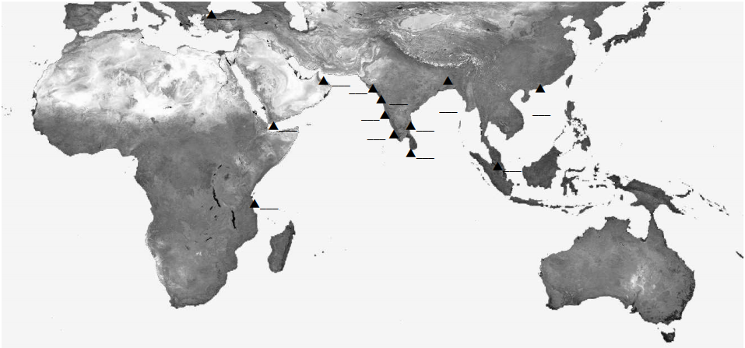
Directions: Label all major port cities during the First Global Era with its corresponding number

- Calcutta, India
- Constantinople (Istanbul), Turkey
- Kilwa, Tanzania
- Aden, Yemen
- Goa, India
- Malacca
- Muscat, Oman
- Ceylon, Sri Lanka
- Surat, India
- Pondicherry, India
- Canton, China
- Diu, India
- Cochin, India

Name: ________________________ Date: ______________ Period: __________________
PART II: Questions for Indian Ocean History Website
Directions: Be sure to answer every question thoroughly and with the best answer possible.
Major Ports
- Kilwa
  - Location:
  - Importance in the Indian Ocean trade:

  - Evidence of creolization:

- Sohar
  - Location:
  - Importance in the Indian Ocean trade:

  - Evidence of creolization:

- Zanzibar
  - Location:
  - Importance in the Indian Ocean trade:

  - Evidence of creolization:

- Goa
  - Location:
  - Importance in the Indian Ocean trade:

  - Evidence of creolization:

- Surat
  - Location:
  - Importance in the Indian Ocean trade:

  - Evidence of creolization:

- Cochin
  - Location:
  - Importance in the Indian Ocean trade:

  - Evidence of creolization:

- Canton
  - Location:
  - Importance in the Indian Ocean trade:

  - Evidence of creolization:

Part II: Short Answer
Directions: For the fill-in the blanks use the Indian Ocean History website to find the best answer for each blank. For the short answer, use the Indian Ocean History website and critical thinking skill to best answer the questions.

- In the late 1400s, the Portuguese explorer, Vasco da Gama, arrived in _____________, a thriving port city located on the Swahili coast. The Portuguese would remain here for two hundred years until the __________________ regained the coast in 1772
- The Mappila community existed on the ____________________ Coast for many centuries. The community was cultivated due to intermarriages between ________________________ and __________________________. This community along with local ______________and _____________communities in the province maintained peaceful trade relations for centuries. This mingling of people goes back at least as far as the 3rd century CE when___________________ was a major port trading pepper as far as Rome and China. Links with traders in the Arabian (Persian) Gulf go back even longer.
- In Ibn Battuta’s trip to East Africa, what line in his documentation shows evidence of cultural exchange or creolization of language? What the spread of what ideology may have influenced this?

- The importance of the Malabar Coast is highlighted as a significant geographical region in the Indian Ocean Trade in both Medieval and First Global Eras. On what accounts, do you see it serving as a multicultural hub. Give examples of Explorers, specific cities, and etc.

Name: _____________________ Date: _________ Period: ________

Quiz: Creolization across the Indian Ocean: Language and Culture
Directions: Be sure to answer every question thoroughly and with the best answer possible.
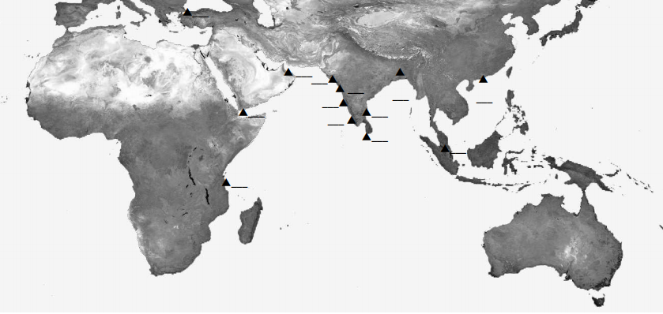
Directions: Place the correct number onto the corresponding port cities.
- Malacca
- Pondicherry, India
- Canton, China
- Diu, India
- Kilwa, Tanzania
- Muscat, Oman
- Calcutta, India

- Constantinople (Istanbul), Turkey
- Goa, India
- Ceylon, Sri Lanka
- Cochin, India
- Aden, Yemen
- Surat, India

Part II: Multiple Choice

- The Mappila community were a mix of ________
  - Arabs and Africans
  - Chinese and Hindu
  - Arab and Hindu
  - Hindu and Africans
  - African and Chinese
- Which major coast served as hub of exchanging language, culture, and religion
  - Ivory Coast
  - Swahili Coast
  - Malabar Coast
  - a and b
  - b and c
- Which of the following languages contain aspects of Portuguese, Arabic, Persian, and Hindi due to the Indian Ocean Trade?
  - Swahili
  - Malagasy
  - Urdu
  - All of the above
- Which thriving port city did Portuguese explorer Vasco de Gama establish the Portuguese in for 2 hundred years?’
  - Zanzibar
  - Kilwa
  - Canton
  - Aden
Short Essay
- In 150-300 words explain, how has the spread of Islam influenced the creolization of languages and culture around the Indian Ocean basin? Give examples from different travelers’ accounts, mixed communities, and other related content that you have researched.

List of Creolized Swahili Words: INSTRUCTORS’ KEY
Word Meaning | Word in Swahili | Root Word | Word Origin
Example:  Of the Coast | Swahili | Sahal | Arabic
Half | Nusu | Nus | Arabic
Travel | Safari | Safar | Arabic
Pen | Kalamu | Qalam | Arabic
Dictionary | Kamusi | Qamus | Arabic
Tea | Chai | Shai | Persian/Arabic
Telephone/wire | Simu | Sim | Persian
Color | Rangi | Rang | Persian
Cotton | Pamba | Panbe | Persian
Table | Meza | Mesa/Mez | Portuguese/Persian
Priest | Padri | Padre | Portuguese
Flag | Bendera | Bandeira | Portuguese
Dice | dadu | Dado | Portuguese
Money | Pesa | Paise/peso | Hindi/Portuguese
Tobacco | Tumbaku | Tambaakoo | Hindi
Car | Gari | Gaadee | Hindi
Glue | Gundi | Gond | Hindi

List of Creolized Swahili Words

Word Meaning | Root Word | Word Origin
Example:  Of the Coast | Sahal | Arabic
Half | Nus | Arabic
Travel | Safar | Arabic
Pen | Qalam | Arabic
Dictionary | Qamus | Arabic
Tea | Shai | Persian/Arabic
Telephone/wire | Sim | Persian
Color | Rang | Persian
Cotton | Panbe | Persian
Table | Mesa/Mez | Portuguese/Persian
Priest | Padre | Portuguese
Flag | Bandeira | Portuguese
Dice | Dado | Portuguese
Money | Paise/peso | Hindi/Portuguese
Tobacco | tambaakoo | Hindi
Car | gaadee | Hindi
Glue | Gond | Hindi

